**Ex:** 3

**Date:** 10/10/2020

**Aim:**

To create a python program to remove and print every second number from a list of numbers until the list becomes empty.

**Program:**

def removeThirdNumber(int_list):

loc=1

poi=0

lenght=(len(int_list))

while lenght>0:

poi=(loc+poi)%lenght

print(int_list.pop(poi))

lenght-=1

lst=[]

print("Size:")

f=int(input())

print("Elements:")

for i in range(0,f):

temp=int(input())

lst.append(temp)

print("Order:")

removeThirdNumber(lst)

**Output:**

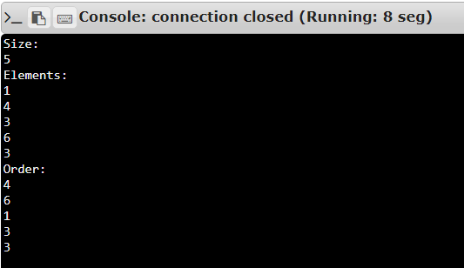

**Result:**

Thus creating a python program to remove and print every second number from a list of numbers until the list becomes empty is done and output is obtained.

**Link:**

<http://103.53.53.18/mod/vpl/forms/submissionview.php?id=231&userid=1652>